# **FIRST FOUNDATION MACHINE TEST - SET 2**

CREATE TABLE EMPLOYEE

(

employeeId INT PRIMARY KEY,

empName VARCHAR(25),

areacode NUMERIC(5),

phone NUMERIC(10),

Email VARCHAR(30)

)

CREATE TABLE MANUFACTURER

(

MfName VARCHAR(25) PRIMARY KEY,

City VARCHAR(25),

State VARCHAR(30)

)

CREATE TABLE COMPUTER

(

SerialNumber INT PRIMARY KEY,

MfName VARCHAR(25),

Model VARCHAR(25),

weight NUMERIC(5,2),

EmployeeID INT,

status VARCHAR(10),

FOREIGN KEY (MfName) REFERENCES Manufacturer (MfName),

FOREIGN KEY (EmployeeID) REFERENCES Employee (EmployeeID)

)

INSERT INTO EMPLOYEE VALUES(1,'Anjali',257,6720374817,'anjali@gmail.com')

INSERT INTO EMPLOYEE VALUES(2,'karun',91,9261739572,'karun@gmail.com')

INSERT INTO EMPLOYEE VALUES(3,'joel',23,3846274058,'joel@gmail.com')

SELECT * FROM EMPLOYEE

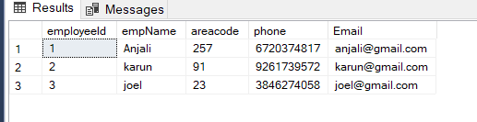

INSERT INTO MANUFACTURER VALUES('Dell','hillcity','South dakota')

INSERT INTO MANUFACTURER VALUES('HP','seoul','South Korea')

INSERT INTO MANUFACTURER VALUES('Asus','beijing','china')

SELECT * FROM MANUFACTURER

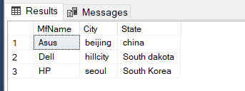

INSERT INTO COMPUTER VALUES(101,'Dell','latitude',2.50,2,'in use')

INSERT INTO COMPUTER VALUES(102,'Asus','expert book',1.50,3,'not in use')

INSERT INTO COMPUTER VALUES(103,'Dell','latitude',2.50,1,'in use')

INSERT INTO COMPUTER VALUES(104,'HP','probook',2,3,'in use')

INSERT INTO COMPUTER VALUES(105,'Asus','expert book',1.50,1,'in use')

SELECT * FROM COMPUTER

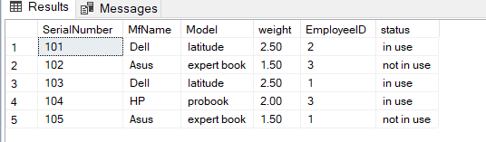

--1

SELECT MfName

FROM MANUFACTURER

WHERE State='South Dakota'

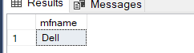

--2

SELECT AVG(Weight) AS Avg_Weight

FROM COMPUTER

WHERE status='in use'

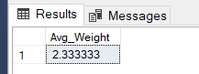

--3

SELECT empName

FROM EMPLOYEE

WHERE areacode LIKE '2%'

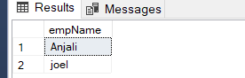

--4

SELECT SerialNumber

FROM COMPUTER

WHERE weight<(SELECT AVG(WEIGHT) FROM COMPUTER)

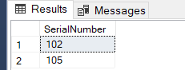

--5

SELECT DISTINCT MfName

FROM COMPUTER

WHERE status='NOT IN USE'

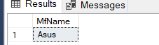

--6

SELECT e.EmpName,c.SerialNumber,m.City

FROM COMPUTER c

INNER JOIN EMPLOYEE e

ON e.employeeId=c.EmployeeID

INNER JOIN MANUFACTURER m

ON m.MfName=c.MfName

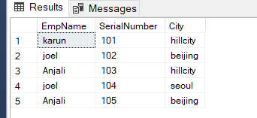

--7

CREATE PROCEDURE get_Info

@empId INT

AS

BEGIN

SELECT SerialNumber,MfName,Model,weight FROM COMPUTER WHERE EmployeeID=@empId;

END

execute get_Info @empid=1

